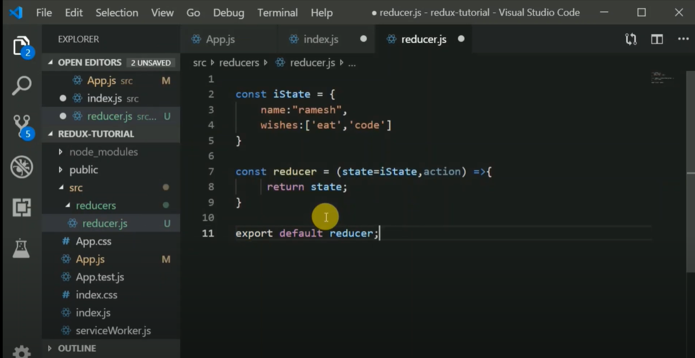

Fig. 1: Reducer

Reducer can only change the state.

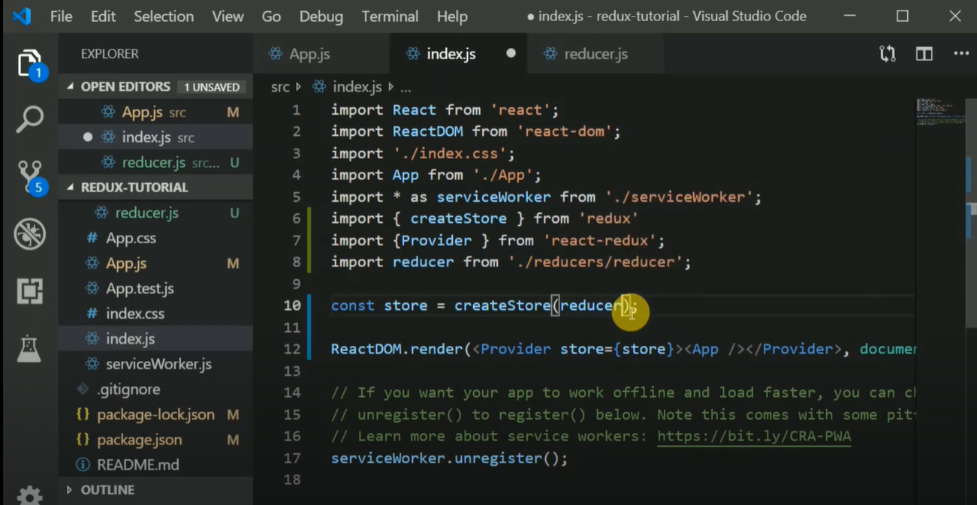

Fig. 2: Store

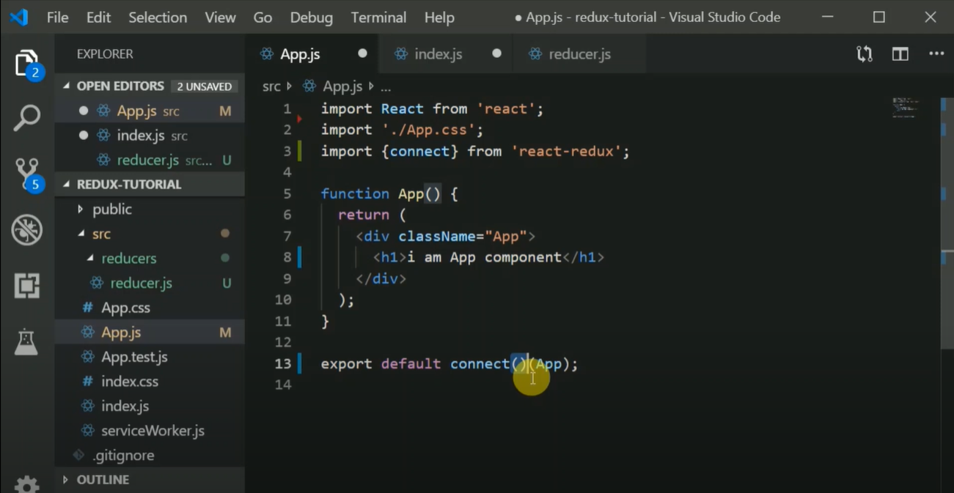

Fig. 3: Connect

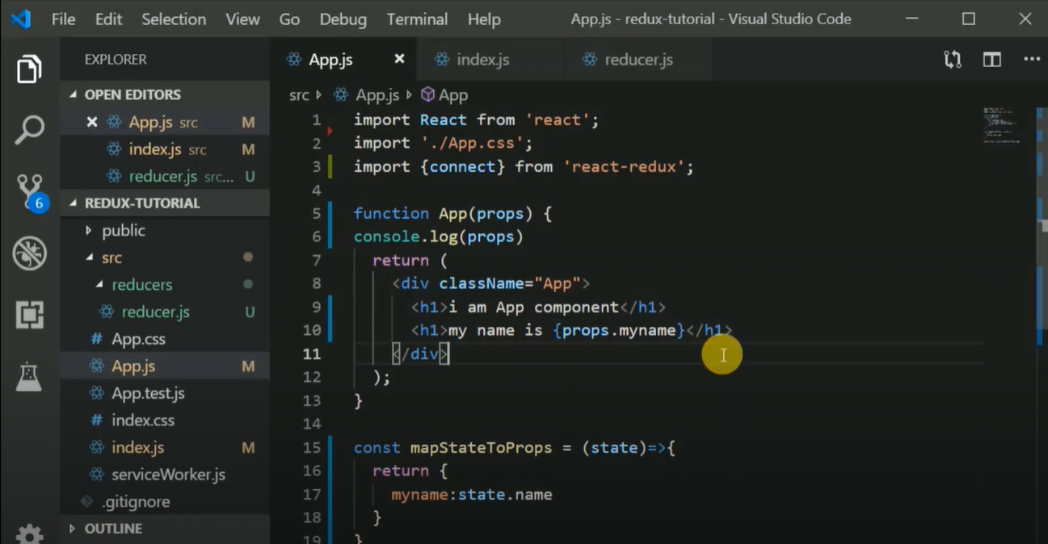

Fig. 4: Map state to props.

Map state to props is used to receive data coming from store.

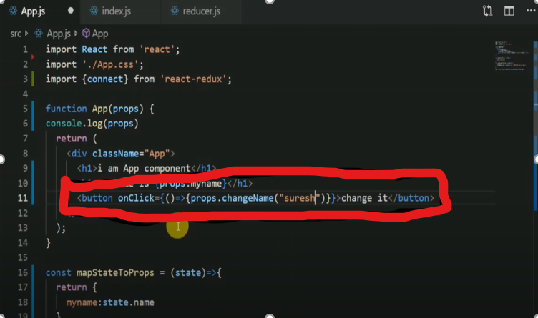

Fig. 5: Calling and passing argument to the function (in reducer)

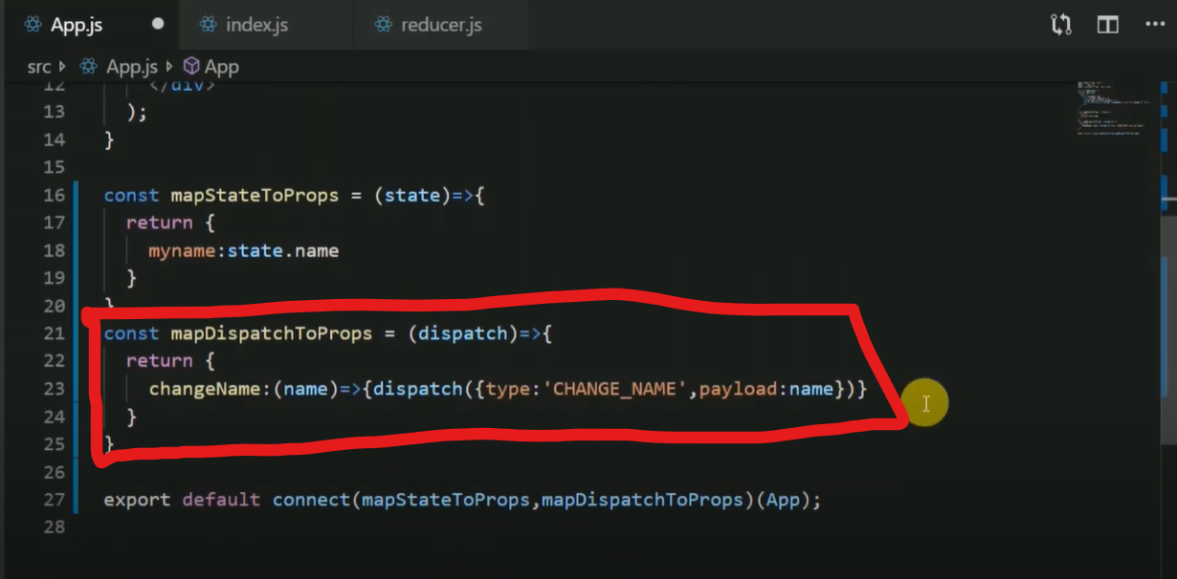

Fig. 6: Defined function in App.js

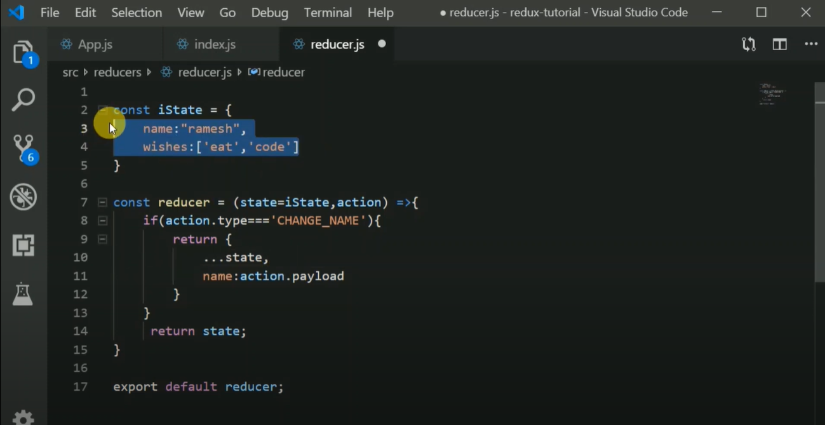

Fig. 7: Logic defined in reducer.

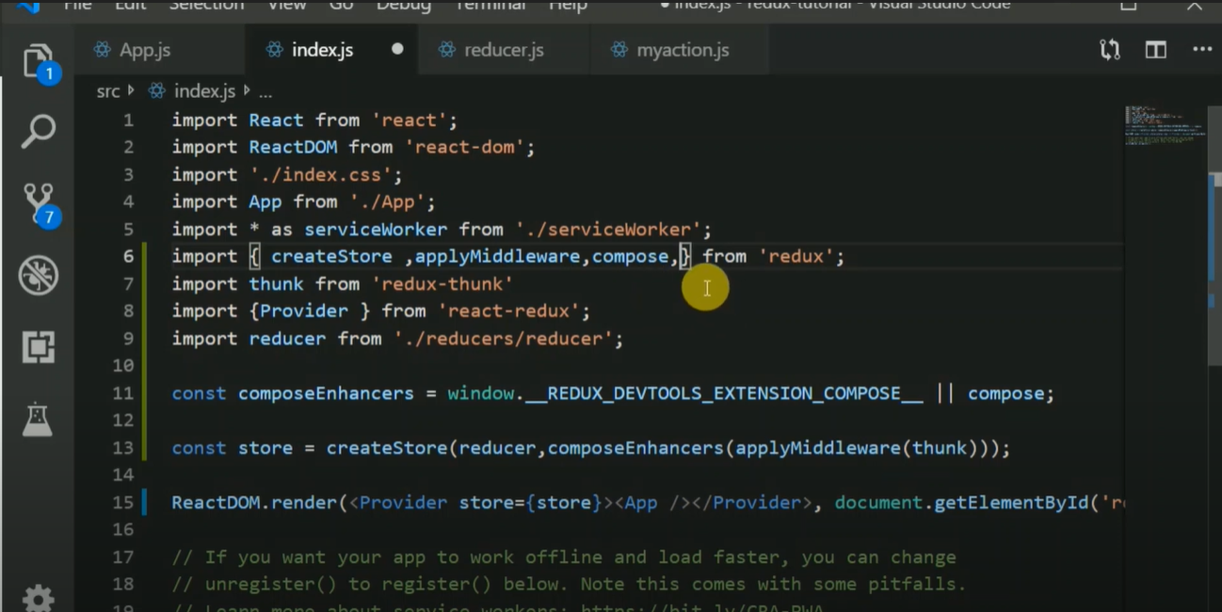

Fig. 8: Store (II)

More than one reducer video link: [Combine reducer](https://www.youtube.com/watch?v=jyp0pR7fpBg)